R&S® ZNB Vector Network Analyzer: setting up the OSP switch matrix

**Preparation**

Preset the network analyzer, and disconnect the LAN cable from the OSP. Turn on the OSP unit.

Preamble: If the grey  pictogram is present in the status bar at the bottom right of the interface (see Figure 1), proceed with the following actions. If not, continue with the instructions below Figure 1.

* Push the Setup button in the System area, and click on the “External devices” tab. Click on “Defines ports” and delete all ports if some have been previously defined. Click on OK;
* Click on the “Switch matrix” button, and click on “Delete all” if devices are present.

At this point the grey  pictogram should have disappeared from the status bar.



Figure 1 – Status bar of the ZNB

Connect a LAN cable between the back of the ZNB and the OSP. Push the Setup button in the System area of the front panel, and click on the “External devices” tab. Click on the “Switch matrix” button and select “Add devices”. In the pop window (shown in Figure 2), make sure that LAN is the interface and enter 192.168.48.147 as the address (IP address of OSP). Select “OSP_6PORTS” as driver, and click OK and then Close.

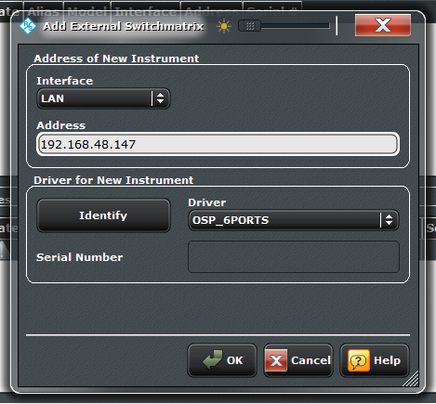

Figure 2 - Window used to add a switch matrix

Finally, click on RF connections, then select the OSP matrix and click on OK. In the pop-up window, map the ports of the VNA to the ports of the OSP matrix. If desired the physical ports can be renamed. Click on OK.

**Maximize the life cycle of the mechanical switches**

By default, a VNA continuously sweep channels. This means that all ports are continuously measured and that the switch matrix will have to switch between several paths to achieve that. If the OSP matrix uses mechanical switches, it is recommended to use single sweeps to minimize the number of switching. To do this, push the Sweep button and click on the “Sweep control” tab. Select Single at the top of the soft panel.

**Setup and calibration**

Figure 3 shows the connections of the input and output ports of the OSP switch matrix to the VNA. Port 1 of the VNA should be connected to Input 1A of the OSP and port 2 to Input 2B. The test cables should be connected to output ports 1 to 6. To ease the connection of the test cables, male to female 2.92 mm coaxial adaptors can be used at the matrix ports.

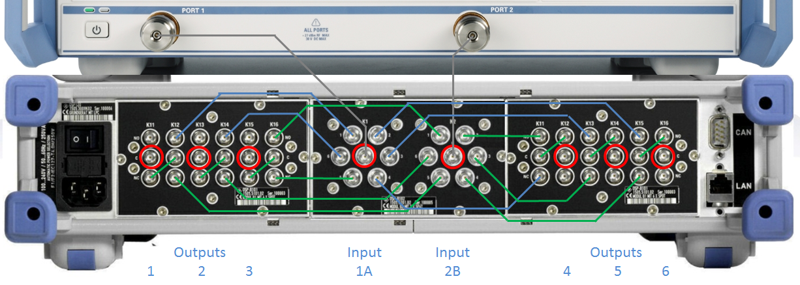

Figure 3 - Connections of OSP switch matrix to ZNB network analyzer

Used and unused ports, as well as logical ports, can be defined in the MEAS >> Balanced ports menu. In this window, unused ports can be set if all ports are not used for a measurement and physical ports can be assigned to logical ports. An example is presented in Figure 4 where ports 3 and 4 are not used, and ports 5 and 6 use logical ports 3 and 4, respectively. This means that S-parameters ports will range from 1 to 4.

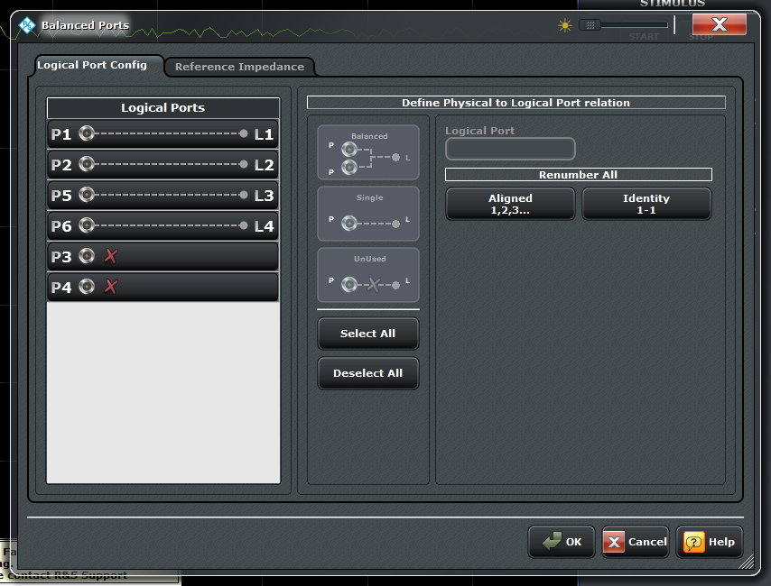

Figure 4 - Definition of used ports and logical ports

For calibration, a calibration unit can be used, e.g. ZV-Z54. Several assignments are necessary, however the number of connections is reduced compared to using a mechanical cal. kit (for more details, see application note 1EZ70 at <http://www.rohde-schwarz.com/en/applications/multi-port-calibration-by-using-a-two-port-calibration-unit-application-note_56280-35331.html>). Figure 5 shows an example of the port mapping between the VNA and the calibration unit (this is for the case previously presented in which ports 3 and 4 are not used). Essentially, port 1 of the VNA is used as a reference, so only port two of the cal. unit has to be connected to the different ports of the VNA.

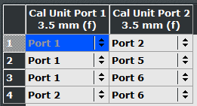

Figure 5 - Connection assignments for calibration

**Powering off the equipment**

Before powering down the VNA, push the Setup button in the System area of the front panel, and click on the “External devices” tab. Click on the “Switch matrix” button and select “Delete all”.

**Firmware upgrade**

To upgrade the firmware, follow the steps below:

* Close firmware (VNA application);
* Save *OSP_6ports.matrix* file in ‘C:\Program Files\Rohde-Schwarz\Vector Network Analyzer\Resources\ExtDev’ folder onto a memory stick;
* Disconnect all USB and LAN cables and devices from VNA;
* Install new firmware;
* Copy OSP_6ports.matrix file from memory stick to the ‘C:\Program Files\Rohde-Schwarz\Vector Network Analyzer\Resources\ExtDev’ folder;
* Launch firmware.